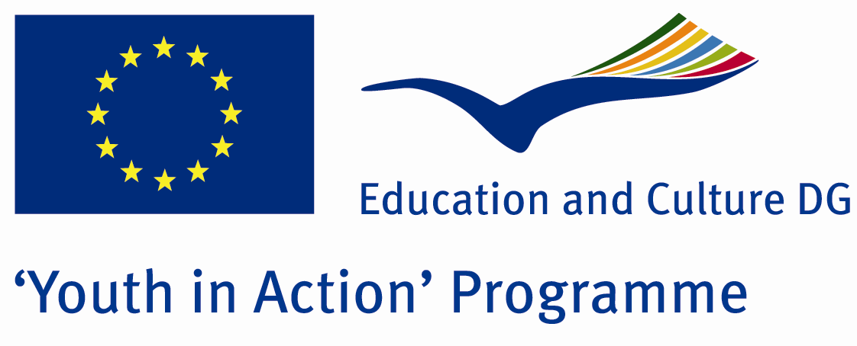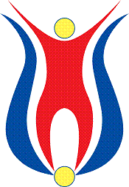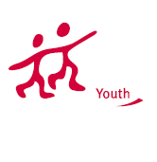

Action 1.1
Project Summary; Would you like to help us in developing our city in enjoyable activities? We need volunteers to attend painting and landscaping activities with the children and the youth. In our project, we welcome all the people who wants to introduce their own cultural drawings and whom dealing with natural beauties.

Project Title; Free Paint, Free Dreams!
Date and Venue ; 08-15 2013 February Turkey
Place: Kilis.

Target Group ; Municipalities, City Councils and Non-Governmental organizations,
youth groups,culture and art groups,e.t.c

Participants ; 5 people from each country (over 18 -25 ). Totally 7 countries.

Conditions ; Accommodation, board and programme costs will be financed through European Commission Youth in Action Programme . Travel costs will be reimbursed in 70% (APEX Tarrifs). Organizations from all 27 EU member countries plus Liechtenstein , Norway and Iceland are eligible to take part.

Working language: English

Organisator group: Group Anatolian Painters

How to apply: If you are interested, please send your Part III forms to
by e-mail please (in word file). Scan Part3 format is enough for application.(Fulfilled Part III which you can find in the attachment, of course signed and stamped) ..

Contact e-mail: groupsymrnes@gmail.com
Group e-mail: anatolianpainters@gmail.com

Deadline to apply:20.09.2012

